Module ICT3715

INFORMATION AND COMMUNICATION TECHNOLOGY PROJECT

|  |  |  |  |  |  |  |  |  |  |
| --- | --- | --- | --- | --- | --- | --- | --- | --- | --- |
| STUDENT NUMBER (Student completes) | | | | | | | | | |
|  |  |  |  |  |  |  |  |  |  |

|  |  |  |  |  |  |  |  |  |  |  |  |  |
| --- | --- | --- | --- | --- | --- | --- | --- | --- | --- | --- | --- | --- |
| IDENTITY NUMBER (Student completes) | | | | | | | | | | | | |
|  |  |  |  |  |  |  |  |  |  |  |  |  |

No handwritten assignments will be accepted.

**INSTRUCTIONS:**

Complete this Front Page (page 1)

Complete the Plagiarism Pledge (page 2). Your assignment will not be assessed without this.

After you have completed the front page with your information, the plagiarism pledge, and Assignment 1 with Section A to D, save the document as a PDF document.

Keep a copy of the original should there be problem with the upload.

PLAGIARISM PLEDGE BY THE STUDENT

1. I have read Unisa’s plagiarism policy.
2. I understand Unisa’s plagiarism policy.
3. I agree to abide by Unisa’s plagiarism policy.
4. I have read the direct copying, plagiarism, and “patch-writing” document.
5. I understand what direct copying, plagiarism, and “patch-writing” is.
6. I undertake to avoid copying directly, plagiarism and patch writing.
7. All academic work, written or otherwise, that I submit is expected to be the result of my own skill and labour.
8. I understand that, if I am guilty of the infringement of breach of copyright/plagiarism or unethical practice, I will be subject to the applicable disciplinary code as determined by Unisa.
9. The marker has the right to refuse to assess the assignment and the system if plagiarism is detected.

Student name and Surname: _______________________________________

Student number: ______________________________

___________________________ ___________

Student signature: Date:

**Assignment 1 [848033]**

|  |  |
| --- | --- |
| **Due date** | Wednesday, 18 May 2022, 11:00 PM |

**Notes:**

This is a compulsory assignment. The assignment contributes to 30% of your year mark.

**System | Online examination file submission system**

Due to the pandemic, the University of South Africa (UNISA) has decided to **conduct all examinations in an online environment.**

The **purpose of this project** is then to look at the digital environment and **design and develop a simulation of such a system, using the real-life scenario and environment.**

You thus have to design and develop an online examination file submission system, that can be presented to the University to be used as an alternative to the current system.

**Note**: You are not allowed to develop any other system or use any other data that was not prescribed or provided to you.

The outcome of this assignment will form part of the design, development, and implementation

of the database and the system. Your implementation effort will be greatly reduced if you take care with the preparation phases of the system.

**Instructions:**

* Make sure that you did complete the instructions on page 1 of this document
* Complete the header and footer with your own information
* Add your practical system content to the document
* Remove everything that is in brackets []
* Make sure that your Table of Content is updated
* Save the document as PDF, e.g., 12345678_ICT3715_01.pdf, (replace 1234568 with your student number)
* When you are done submit via myModules 2022 on the Module Site under Assignment 1

Table of Contents

1 Assignment 1 7

1.1 Section A [4] 7

1.1.1 Programming Languages (2) 7

1.1.2 Database (2) 7

1.2 Section B [10] 7

1.2.1 Cleaning the data 7

1.3 Section C [10] 7

1.3.1 Activity Diagram (7) 7

1.3.2 ERD Diagram (3) 8

1.4 Section Backup and Recovery for the Database and Programming code [6] 8

1.4.1 Backup and Recovery Software for the Database (3) 8

1.4.2 Backup and Recovery process for the Programming code and your Portfolio (assignments) (3) 8

# Assignment 1

## Section A [4]

### Programming Languages (2)

[Identified the programming languages that you will use to develop your system]

[PHP, Javascript, JQuery, Bootstrap]

### Database (2)

[Identified the database software that you will use to develop your database]

MySQL, PHPMyAdmin, MariaDB

## Section B [10]

### Cleaning the data

[Download the data file from Additional Resources on the myModules 2022 Site]

[Add a column in your Table for the Staff member (this is the lecturer or the staff member from the Exam Department) password and the Student password]

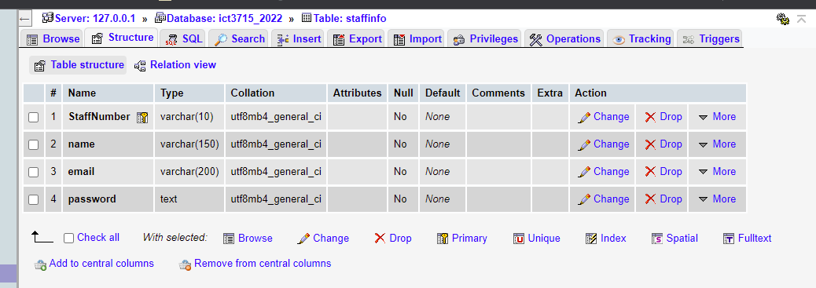

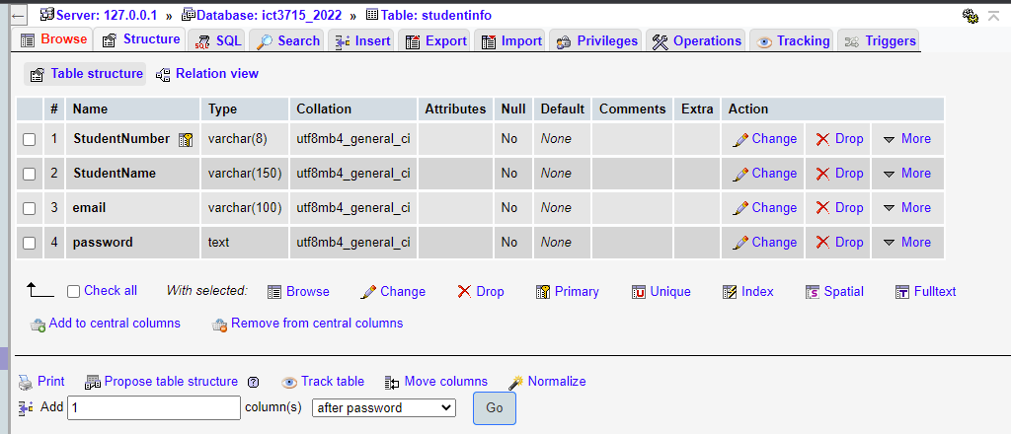

[Add a column for the student e-mail, use the student number given in the table and add @myLife.unisa.ac.za after the student number]

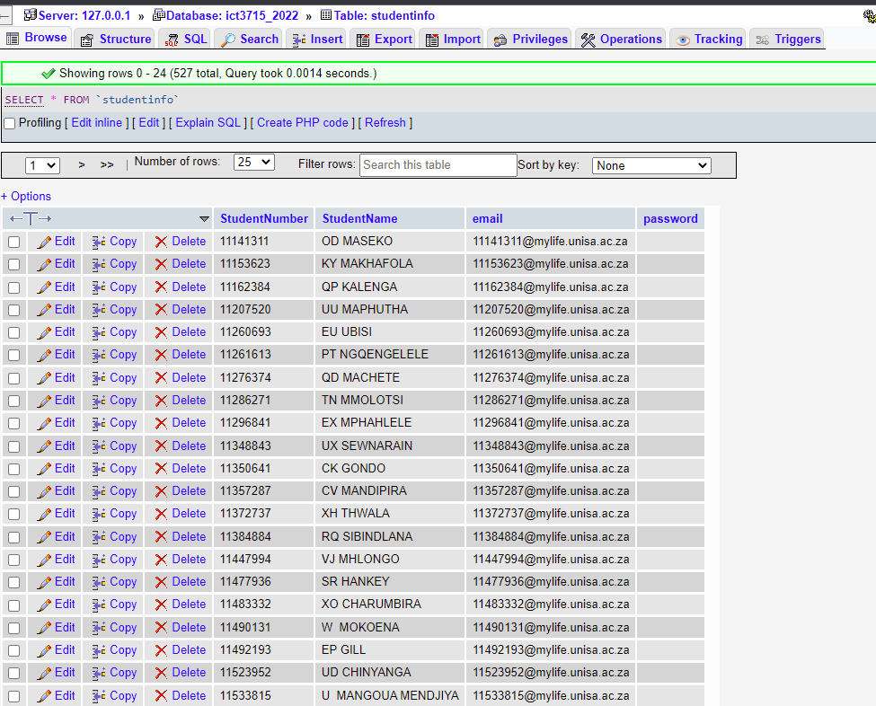

[Follow the processes to clean the data. Extract the cleansed data into a .csv file. Attached the .csv file to the end or your assignment]



## Section C [10]

### Activity Diagram (7)

[Get the Activity Diagram from 14. 5. System | Data flow diagram on the myModules 2022 Site]

[You must change the Activity Diagram to add one part so that the Exam Department, Lecturer, and the Student when logging on to the system they have to be verified (against the data in the database) and also use a password with the login]

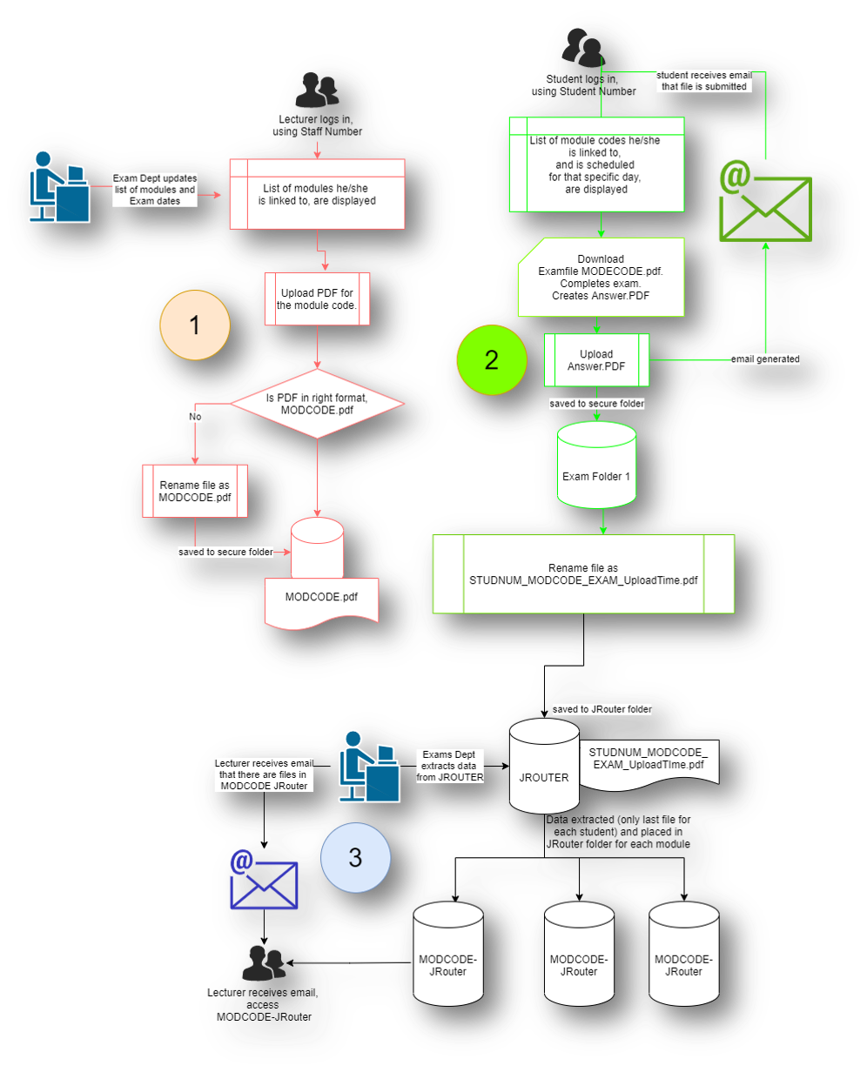

### ERD Diagram (3)

[Get the ERD Diagram from 13. 4. System | Database and the ERD on the myModules 2022 Site]

[You must make sure that you understand the ERD diagram and the table given below the ERD diagram on the 13. 4. System | Database and the ERD on the myModules 2022 Site so that you can start creating the database]

[Make sure that your ERD diagram is correct after you have completed Section B]

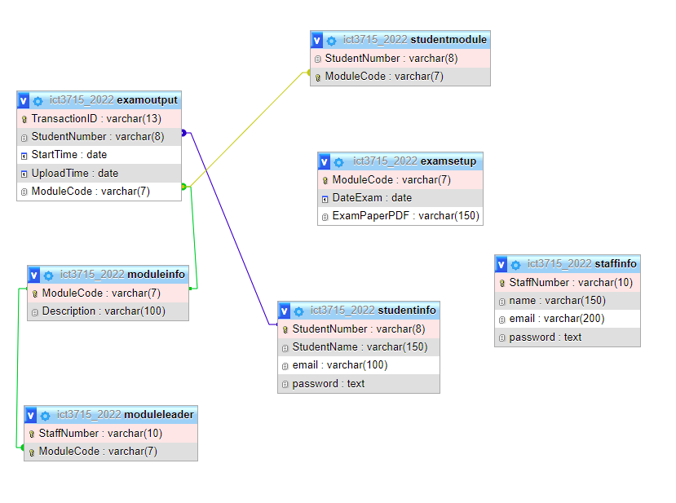

## Section Backup and Recovery for the Database and Programming code [6]

### Backup and Recovery Software for the Database (3)

[Identified two types of software that you can use for the backup and recovery of your database. Remember software must be free and not have a trail period, that can expire before your examination of your system at the end of the year]

[GitHub, 000Webhost, mySQLWorkBench]

### Backup and Recovery process for the Programming code and your Portfolio (assignments) (3)

[Identified what process / software you can use for the backup and recovery of your programming code and your Portfolio (assignments). Remember software must be free and not have a trail period, that can expire before your examination of your system at the end of the year]

[GitHub, 000Webhost, mySQLWorkBench]